|  |  |
| --- | --- |
| Description: EGC_Black | Student Name \_\_\_\_\_\_\_\_\_\_\_\_\_\_\_\_\_\_\_\_\_\_\_  **Eastern Goldfields College**  Mathematics Methods 2017  Test 611 - Calculator Free Section |
| Working Time: 15 minutes | Total Marks: 14 marks |

**Question 1** **[ 4 marks]**

Find *y* as a function of *x* given = 4*x*3 +15*x*2 – 14*x* and *y* = 1 when *x* = 1

**Question 2 [4 Marks]**

Find all stationary points on the curve 

**Question 3 [6 Marks: 2, 4]**

The tangent to the curve at (2, 18) has a gradient of 17.

1. Find the equation of the tangent line to the curve though (2, 18)
2. If *a* and *b* are positive integers, find the vales of *a* and *b* and the gradient function

|  |  |
| --- | --- |
| Description: EGC_Black | Student Name \_\_\_\_\_\_\_\_\_\_\_\_\_\_\_\_\_\_\_\_\_\_\_  **Eastern Goldfields College**  Mathematics Methods 2017  Test 611 - Calculator Assumed Section |
| Working Time: 45 minutes | Total Marks: 41 marks |

**Question 5 [8 Marks: 2, 4, 2]**

A rectangular block of land has the following dimensions.

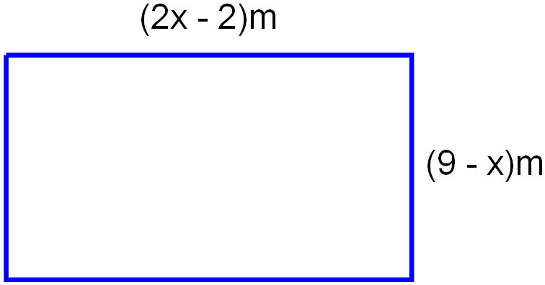

1. Show that the area (A) of the block of land in square metres can be expressed as

A = -2*x*2 + 20*x* – 18

1. Use calculus techniques to find the value of *x* that will maximise the area of the block. Show that it is a maximum.
2. Find the maximum area that the block could be.

**Question 6 [5 Marks: 2, 1, 2]**

For the function y = x3 – 3x2 – 22x + 24 over the domain -4  x  8

1. Find any stationary point(s) for the above function.
2. What are the coordinates of any point(s) of inflection?
3. Find the global maximum and minimum value of the function.

**Question 7 [6 Marks: 1, 1, 2, 1, 1]**

The population (P) of a certain species of fish in a lake after t years could be calculated by the formula

P = 4t3 – 48t2 + 140t + 250

1. What was the initial population of fish?
2. What was the population after 4 years?
3. What was the rate of change in the population at 4 years?
4. Some fish in the lake began to contract a deadly disease. When did the disease appear to initially affect the fish?
5. A treatment was discovered for the disease. When did it appear that the treatment was introduced to the fish?

**Question 8 [5 Marks]**

Sketch the graph of a function that satisfies all of the conditions stated below. (You do not need to determine the equation of such a function).

* As  and as 
* The function cuts the x-axis at (-7,0), (-1, 0) and (5,0) and nowhere else.
* The function has a y-intercept at (0, 3)
* The gradient of the function is zero for x = -4 and 2.
* The gradient is positive for  and negative elsewhere, except where it is zero.



**Question 9 [7 Marks: 3, 2, 2]**

A triangular prism is shown. The base of the triangle is 20 cm long. The sum of the height of the triangle (H) and the length of the prism (L) is 62 cm.

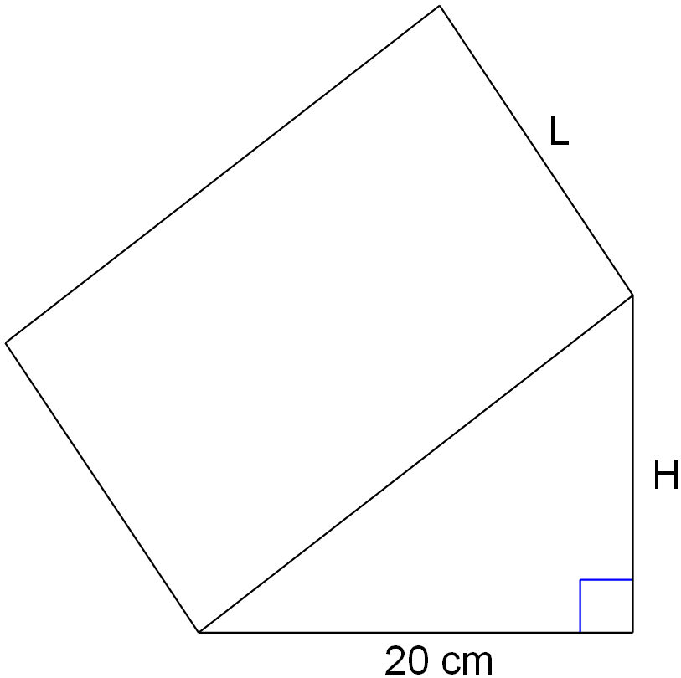

L + H = 62

1. Write an expression for the volume of the prism in terms of H.
2. Determine the value of H that will give the largest volume.
3. What is the largest volume for this triangular prism?

**Question 10 [10 Marks: 1, 3, 4, 1, 1]**

The displacement s (in metres) at time *t* (in seconds) of a particle moving in a horizontal straight line is given by

s(t) = (t - 3)(2t + 3)(t – 6).

Find:

a) the initial displacement of the particle

b) Use calculus to determine when the particle changes direction.

c) The total distance travelled in the first 5 seconds (to the nearest metre).

d) The velocity of the particle when t = 5

e) The average speed of the particle over the first five seconds.